Ping and Tracert (Traceroute)

What Is Ping and Tracert (Traceroute)?
# Source: Chatgpt (GPT‑5 Mini) at [1/13/2026]
Ping and Tracert (Traceroute) are basic network diagnostic tools used to test and analyze network connectivity. They are often built into Windows and other operating systems.

1. Ping
# Source: Chatgpt (GPT‑5 Mini) at [1/13/2026]
- Purpose: Checks if a device or server is reachable over a network.
- How it works: Sends small data packets (ICMP echo requests) to a target device; if the device is reachable, it replies (echo reply).
- What it tells you:
  - Whether the device is online
  - Response time (latency)
  - Packet loss
- Example: ping google.com → tells if Google is reachable and how fast the connection is.

2. Tracert (Traceroute)
# Source: Chatgpt (GPT‑5 Mini) at [1/13/2026]
- Purpose: Shows the path data packets take from your device to a destination.
- How it works:
  - Sends packets with increasing TTL (Time To Live) values.
  - Each router (hop) along the path that decrements TTL to 0 sends a reply.
  - This reveals all intermediate devices between your device and the destination.
- What it tells you:
  - The route packets take
  - Which routers may be causing delays
  - Where connection failures occur
- Example: tracert google.com → lists all routers between your PC and Google’s server.

Key Difference
# Source: Chatgpt (GPT‑5 Mini) at [1/13/2026]
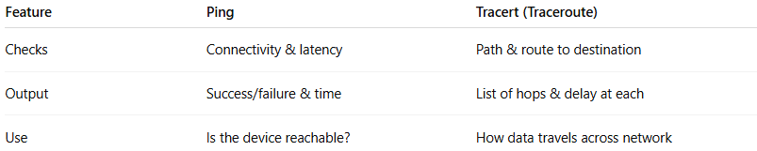
Feature | Ping | Tracert (Traceroute)
Checks | Connectivity & latency | Path & route to destination
Output | Success/failure & time | List of hops & delay at each
Use | Is the device reachable? | How data travels across network

Short definition (exam-friendly):
# Source: Chatgpt (GPT‑5 Mini) at [1/13/2026]
Ping is a tool that checks if a device is reachable and measures response time, while Tracert (Traceroute) shows the path and delays of packets from source to destination.

